Forbush Corner Nordic
Capital Campaign
2021/2022

Help us continue to make Forbush Corner Nordic a world class cross-country ski destination!
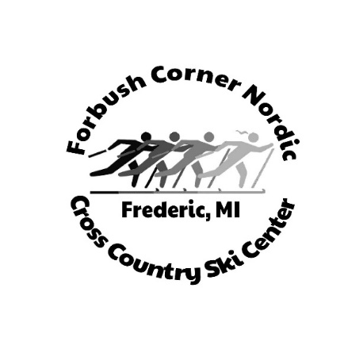
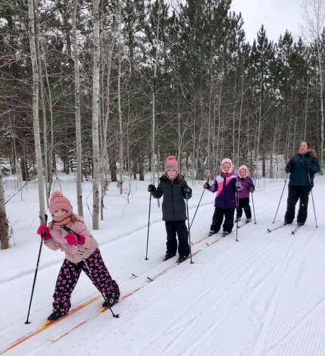

Thank You for your continued support!

Forbush Corner Nordic Capital Campaign

The history of Forbush Corner Nordic started in the mid 1800’s when it was the Ward orchard. One of the largest orchards east of the Mississippi. It stretched across I-75 to the west and north of Roberts Rd. You can still see some of the old apple trees around the property. The apples continue to make some of the best apple pies and applesauce. Just this summer when we were putting in the footings for the new yurt, we discovered some of the old barn foundations. This little farm that Dave’s great grandparents owned has now turned into one of the best places for cross country skiing. Dave had a vision and worked extremely hard to create this cross-country skiing gem. You can see it in his trail design, how he converted the old farmhouse into a quaint little ski shop and the pride he took in maintaining and grooming his trails to perfection. Even 35 years ago, Dave knew the best grooming came from using a PistenBully groomer.
In 2012, when Dave was setting up his trust to pass his beloved trail system down to 5 new owners, none of the 5 thought that day would ever come. When Dave passed, way too soon in 2014, it left the 5 new owners with some huge shoes to fill. Fortunately, we all had the same vision and passion to keep Dave’s dream alive. The first couple years without Dave was rough. We just barely scraped by most seasons and survived with some creative bill paying and an all-volunteer work force. Still, we knew what Dave always knew, that great grooming comes from a PistenBully groomer. The PB groomers we were using were aging and failing. So, we decided to use some of the trust money as a down payment on a 2002 refurbished PB 100. We did not know if we would be able to pay off the remaining loan or not, but we took the leap. Through some generous donations and increased revenue, the loan was repaid. The new groomer was just what we needed to bring back the perfection of trail grooming worthy of the Forbush Corner name.

Snowmaking and Non-profit Status

In 2019, Forbush Corner was approached by Frank Nizio with the offer of a monetary donation to install state of art snowmaking equipment. At that time, it seemed in everyone’s best interest to become a non-profit. All five owners decided to donate all their Forbush Corner land holdings, buildings and equipment into a new non-profit called Forbush Corner Nordic and become directors instead of owners. It proved to be the right move to share this little cross country skiing gem with the community. 2019-2020 was one of our best years to date.
However, 2020 turned into one of the most challenging years ever. The pandemic ended the season way too early. Uncertainties seemed to be all that was certain. Yet, we decided to reinvest some money back into the Nordic center. We did some remodeling inside the shop, painted the exterior and interior of the shop, sold some equipment, and bought a much-needed tractor. Lastly, we built a yurt for increased social distancing. This was all made possible by the generous support of our cross-country skiing community.
Now the time has come to launch our first capital campaign. The snowmaking loop is just wonderful to ski, as many skiers will attest to. Especially in the early season when there are no natural snow options. When we make snow, we make a lot of snow. It typically takes two days to push all the snow around, during which time we need to close the snowmaking loop. We have been using our 18-year-old PB 100 to move the snow, but it is tough on that machine to move those big piles of snow. It was not really intended for that. So, once again we took a leap of faith and bought a brand new PB. It has a longer wheelbase/track and increased power to move the snow piles around more easily and quickly. This means we can get the trails opened sooner and save our other PB 100 for grooming. The two machines enable us to have a backup when one goes down with mechanical problems and it will allow us to groom the snowmaking loop more efficiently.

Phase 1- Purchase the new PB 100- $229,000

Frank Nizio has willing helped with $50,000 towards the down payment and Forbush Corner Nordic has provided the remaining $29,900 to purchase the groomer. This leaves a balance of $150,000.
The Kassbohrer Company is letting us take out a 4-year loan to pay off the remainder of the costs. We are also hoping to pay off the loan early to avoid some of the interest payments. In addition, the PB 130 was sold and the Bombardier will be sold or scrapped to help pay off the loan. Fiscally speaking though, we cannot make all those payments without help from the capital campaign. Therefore, we are looking for an additional $75,000 to help us make the remaining loan payments.

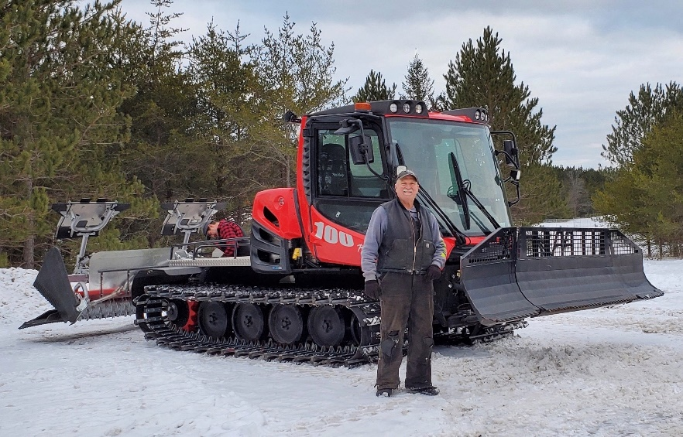

Phase 2- Land acquisition

We have an opportunity to purchase two 40-acre parcels of land south of our current east side trails. This is an extremely exciting option as it will allow us to add more trails and give us a way to get to our Pines loop without using the seasonal roads that are also used by snow mobile riders. The cost would be around $1,500 an acre or around $120,000. It is exceedingly difficult to get a loan for a non-profit, especially one with such thin margins like a cross country ski area. If we cannot raise the entire amount, the landowner has agreed to a possible land contract. The total campaign will be for $200,000.
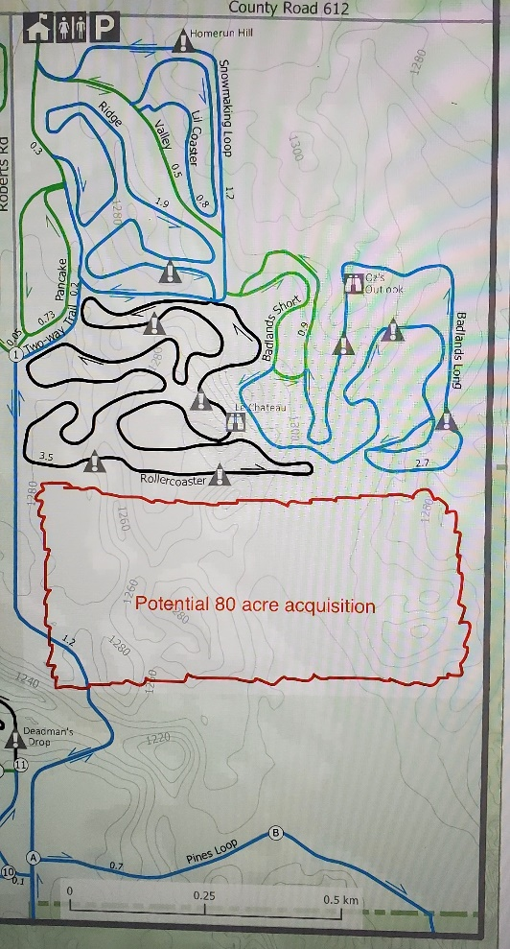

Sponsor level: It is only through the donations of the skiing community that we can continue to improve Forbush Corner Nordic trail system.

$5,000 + - Gold Level - Snow stick sponsors will receive a plaque by a snow stick, Name on a plaque in the shop, a custom pottery Forbush Corner Nordic mug, and acknowledgement in the yearly report of donors.

$2,500 - $4,999 - Silver Level - Trail sponsors will get their name on a plaque by one of our trails, Name on a plaque in the shop, a custom pottery Forbush Corner Nordic mug, and acknowledgement in the yearly report of donors.

$1,000 -$2,499 - Bronze Level- Name on a plaque in the shop, a custom pottery Forbush Corner Nordic mug, and acknowledgement in the yearly report of donors.

$500-$999 - Sponsor Level- a custom pottery Forbush Corner Nordic mug, and acknowledgement in the yearly report of donors.

< $500 - Friend Level- acknowledgement in the yearly report of donors.
Contributions can be made through our website, through an individual’s charitable mutual fund, or by check.
- We are registered with GuideStar and with the state of Michigan.
- Checks should be made out to Forbush Corner Nordic and mailed to the following address.

Forbush Corner Nordic
PO Box 118
Gaylord, MI 49734
989-889-2843

2019-2020 revenue and expense report
-(We are still filing our first yearly 990 form for the non-profit, so figures may change slightly)

2019-2020 expenses 2019-2020 income
Operating expenses- $ 84,644 Shop sales- $65,856
Taxes/insurance/etc.- $ 15,104 Trail fees- $61,197
Snowmaking expenses-$ 13,352 Logging- $ 1,558
Total expenses- $113,100 Total income- $128,611

Capital outlay in 2020
Shop remodel- $ 5,489
Yurt- $26,031
Tractor- $17,000
Total capital improvements- $48,520

2020 capital outlay revenues
Otsego Economic Alliance grant- $ 8,000
Bob Thayer Memorial fund- $ 4,612
Donations- $ 4,000
Forbush Corner Nordic- $31,908
Total- $48,520

