Mission Statement  Our mission is to promote social welfare through the enjoyment and appreciation of the natural environment and the promotion of activities that emphasize healthy, family-oriented winter outdoor sporting activities related to cross-country skiing and snow shoeing.  Directors  President- Howard Hansen Treasurer- Ann Wagar  Secretary- Todd Hubbard  Director- Larry Damic Director- Mario Kennedy  Contributions can be made through our website, through an individual’s charitable mutual fund, or by cash/check.  - We are registered with GuideStar and with the State of Michigan.  - Checks should be made out to Forbush Corner Nordic and mailed to the following address.  Forbush Corner Nordic  PO Box 118  Gaylord, MI 49734  989-889-2843 | Capital Campaign Update  December, 2021  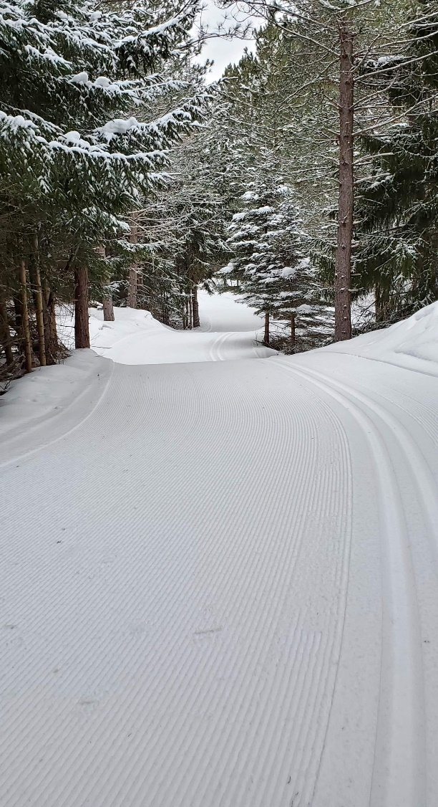

Capital Campaign winter 2021  Groomer loan- We really wanted to knock down the interest owed on the new PB 100 groomer. The final pay-off on this loan was $185,500 because it was at 9% interest on the $150,000 principal (yikes!). Getting a lower rate on an equipment loan through a bank proved to be difficult due to the nature of our seasonal dependent business and being a non-profit.  Fortunately, we had two people step forward and offer us personal loans with a simple 4.5% interest rate. So, we applied the $40,000 we had allocated for the first payment and $35,000 from the capital campaign to get the groomer loan principal down to $85,000, plus the 4.5% interest. This move will save us around $16,000 in interest payments. Maybe more if we can pay the personal loans off sooner. This saves us a significant amount of money and we truly appreciate those two individuals for loaning us their money.  Due date Principal Interest Payments due  8/2022 $21,250 $3825.00 $25,075.00  8/2023 $21,250 $2868.75 $24,118.75  8/2024 $21,250 $1912.50 $23,162.50  2/2025 $21,250 $ 956.25 22,206.25  total 85,0000 $9562.50 $94,562.50 | Land Acquisition  The two 40 acre parcels we are planning to buy is still moving forward. The landowner wants to set up a 4-year transition plan, but still allow us to develop trails in the off season.  Due date Jan 2022 Jan 2023 Jan 2024 Jan 2025  Allocated $33,500 $17,500  debt $16,000 $33,500 $33,500  Purchase price $134,000  Allocated funds $ 51,000  Remaining Debt $ 83,000  In six months, we have raised $88,000 of our $200,000 goal. We still have 177,500 in debts that will be helped by any future funds raised by this campaign. We have come a long way in making Forbush Corner an even better place to ski.  Future Plans  Going forward past this campaign, our plans will include the following listed needs and wants.  Needs-  - Pole Barn extension to accommodate the larger groomer and to house all the equipment to prevent further weathering.  - New utility vehicle for trail work in the off season and on the snow for grooming or moving snow making equipment.  Wants:  - Extend the snowmaking system  - A biathlon shooting range

